AI ASSISTED CODING
LAB ASSIGNMENT-1.5
Name: M.Meghana
Hallticket No: 2303A52505
Batch: 50

Task 1: AI-Generated Logic Without Modularization (String Reversal Without
Functions)
Prompt:
#write a python program to print reversal of string in dynamic way without user defined functions
Code:
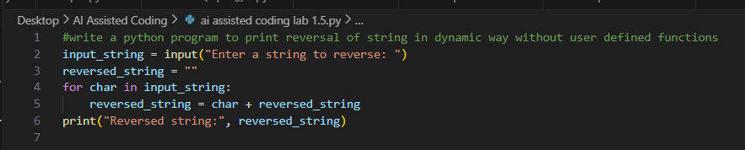
Output:
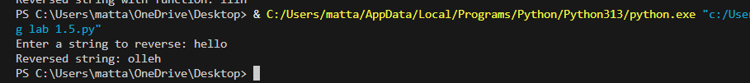
Justification:
This program reverses a string using direct logic without any functions. It takes input from the user. All the code is written in one place, so it is easy to read and follow. The flow of execution is simple and clear. This approach is ideal for beginners learning basic string operations.

Task 2: Efficiency & Logic Optimization (Readability Improvement)
Prompt:
#generate optimized code for string reversal
Code:
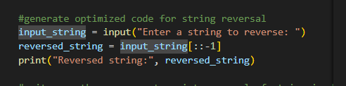
Output:
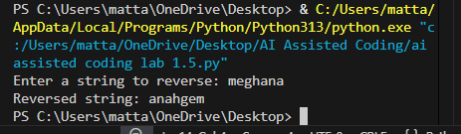
Justification:
The optimized code is easier to read and maintain because it removes extra variables. It avoids complicated index-based logic, making the code cleaner. Looping directly through the string makes the reversal easy to understand. This helps other developers quickly review the code without confusion. It still meets the requirement of writing the logic inline without functions.

Task 3: Modular Design Using AI Assistance (String Reversal Using Functions)
Prompt:
#write a python program to print reversal of string in dynamic way using functions with meaningful comments
Code:
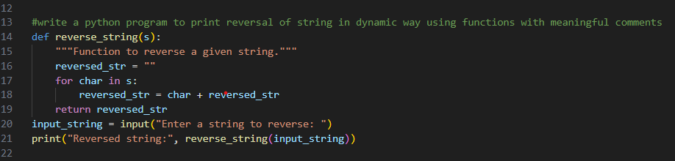
Output:
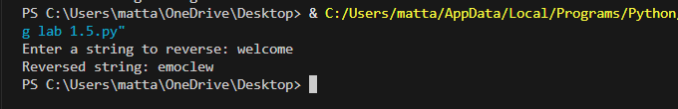
Justification:
Using a function for string reversal makes the code more organized and reusable. The same function can be used in many places without rewriting the logic. Keeping the logic inside a function makes the program easier to maintain and debug. This is helpful when the application becomes larger. AI-generated comments help others understand the code quickly.

Task 4: Comparative Analysis – Procedural vs Modular Approach (With vs
Without Functions)
Prompt:
#generate a python code to print string reversal with functions and without functions and code to print comparison table of code clarity,reusability,debugging ease and suitabilityfor large applications
Code:
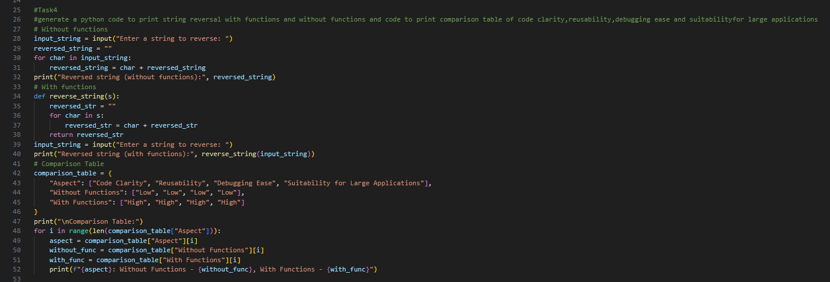
Output:
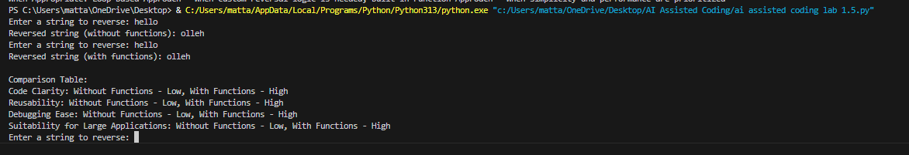
Justification:
Writing the code without functions is simple and easy to follow, especially for beginners, because everything is in one place. However, as the program becomes bigger, this approach can get messy and hard to manage. Using functions helps keep the code clean and organized, and the same logic can be reused whenever needed. It also makes finding and fixing errors much easier. Overall, the functional approach works better for larger and real-world applications.

Task 5: AI-Generated Iterative vs Recursive Fibonacci Approaches (Different
Algorithmic Approaches to String Reversal)
Prompt:
#write a python program to print string reversal in loop based approach and built in function with comparsion of execution flow,time complexity,performance for large inputs and when each approach is appropriate
Code:
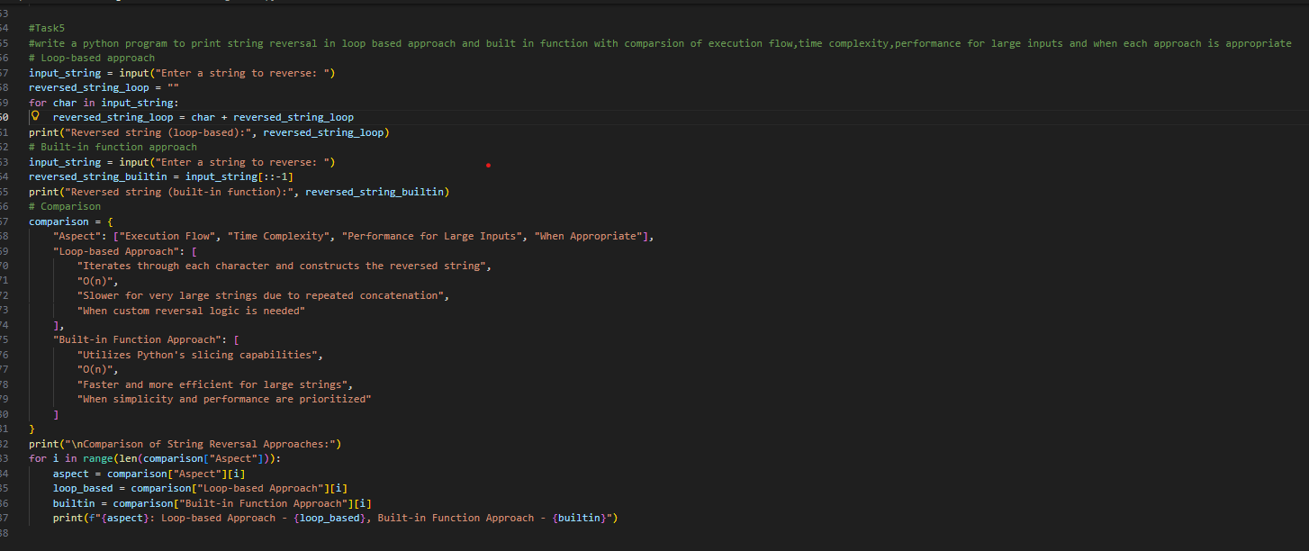
Output:
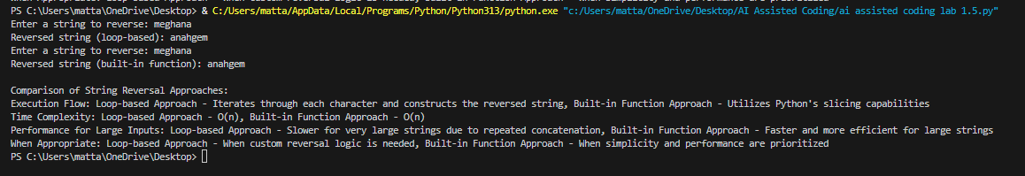
Justification:
The iterative approach is simple, fast, and works well for large strings without using extra memory. It is more practical for real-world applications. The recursive approach is clean and easy to understand, but it uses more memory and can be slow for long inputs. Recursion is useful for learning, while iteration is better for performance.

